LGCWEEK xXx - ???????
Colour key - Venn Jordan Pedro
The Jordan
https://meet.jit.si/jordan9000#config.disableAP=true&config.disableAEC=true&config.disableAGC=true

The Pedro
https://meet.jit.si/pedro9000#config.disableAP=true&config.disableAEC=true&config.disableAGC=true

Need to remember - post finished show in google Linux group.

PICK YOUR FUKIN’ STORIES!

Remember to ask shatrealm to come up with Show Title.

Intro-
grep ^http links.txt | tr "\n" " " | sed 's/\&/\\\&/g' | xargs firefox lynx curl

Vote for Showtitles: vote.linuxgamecast.com

INTRO : ???????????????????????????? <- !!!!!!!!!!!!!!!!

Rundown:
Protontricks needs a new maintainer
Because the developer went back to the loving embrace of Windows.
And we get our first RTX title on Linux
It’s Q2 but hey, still had RTX.

Artifact Continues to tank
- Karn you believe it?
Once again, we learn never lead your beaver undefended
- Especially when it’s backing your game server

Steam hits 30’000 games
- And most of them are not particularly good
And after having a bit of an uproar on their hands
- Unity backs down from the shaky-ass ground they stood on

What we’re up to :
V -
J -
P -

Colour key: Venn Jordan Pedro
Party Patreons: Post story suggestions HAR!

1. GOG downloader/updater for Linux (CLI)
https://www.reddit.com/r/linux_gaming/comments/agnz4w/i_made_a_commandline_gog_game_downloaderupdater/
- https://github.com/nicohman/wyvern
2.
3.
4.
5.

Links
Steam: News

Proton force
https://steamcommunity.com/groups/SteamClientBeta#announcements/detail/1703951108827819236
- VALVe! Are you feeling alright?
- Two Steam updates in the same week with a bunch of actual fixes on Linux and feature requests introduced.
- Have a seat. You must be positively exhausted, after this one!
- You can pick-and-choose versions, neat.
- People are reporting controllers working in games where they once did not.
- Hey look, Steam controlla now works with Dead Smells.
- 5 years later...
  - 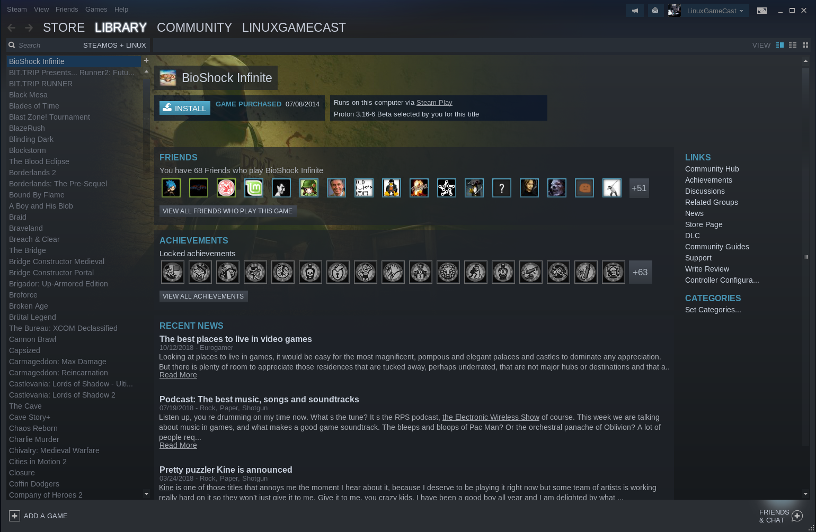
  - Meh, no joy.
- Tombs is a little bit faster /w DXVK.
- https://twitter.com/Plagman2/status/1086194569010507776
  - That guy in the thread.
- Spanks Row 2 runs.
  - And it runs a bit better with Proton than either the VP port or the regular WINE version.
    - Saints Row 4 does as well. Can even get it to squeeze out 30fps on the vega 11
- Steam overlay gets its own vulkan nerve pinch
- Also IPV6 support for game downloads
- Host of linux fixes as well including upgrading gnutls, and some better process management
- No more 0 byte heresy updates!
- I too tried the VP games but it seems as though the DX11 ones don’t start with Proton.

300,000
https://www.pcgamer.com/steam-now-has-30000-games/
- And still nothing to play
- This would be more impressive if it took more than $100 to get on Steam.
- That’s why 50% of that number is games from the past two years

2018 year in review
https://steamcommunity.com/groups/steamworks#announcements/detail/1697194621363928453
- "The technology behind Trusted Matchmaking on CS:GO is getting an upgrade and will become a full Steam feature that will be available to all games."
  - Another reason to consider Steamworks for your multiplayer bits.
- Their bit about establishing a large scale private network is a bit of neat news to the network engineer in me
- Also, we’re getting promises of an “updated library”, so get ready to hate it!

Going down
https://gaminglyf.com/news/2019-01-15-valves-artifact-hits-new-player-low-loses-97-players-in-under-2-months/
- The Dec update didn’t help.
- Protip: Don’t put an entry fee on a game with an oversaturated market.
- Listen, I’m grateful for what Valve have done for Linux gaming but developers who actually want to make games left Valve years ago.
- I know for a fact the “long drawn out matches” can put people off, it certainly did for me.
- There is no point releasing anything that does not end /w a 3.
- And now we’re taking bets on the amount of time before it goes free to play
- People seem to gravitate more towards free shit

RIP Trix
http://www.twitlonger.com/show/n_1sqpgb1
- Good.
- To be fair, the one thing protontricks does different than Winetricks is save you from having to write the complete WINEPREFIX=/path variable.
- Maintaining it shouldn’t take much.
  - And that’s the beauty of open source. Your project can outlive you
- Though it would be great to see someone pick it up and expand the functionality.

Steamulator
https://www.reddit.com/r/linux/comments/agc3b4/legality_of_releasing_the_code_for_my_steam/
- One way to find out.
- It usually only takes a couple of emails to Steam support to get to a human.
- If you’re clear about wanting to talk someone in the legal department, they’ll be pretty quick to accommodate.
- That’s how I got the official A-OK from them to redistribute the client from an official distro repository, with the caveat that no part of it would become affected by the GPL.
- Basically, you want to go to them directly and wait.
- If you do what Tomas Duda (of Truck Simulator fame) did, VALVe will nuke your account.
- I have an inkling that because this could potentially enable game piracy, Valve might want to put the kibosh on this
- Or maybe they’ll surprise us by open sourcing stuff
Steam: Game Updates

Gravel
https://steamcommunity.com/games/558260/announcements/detail/1714084207992315550
- Oh! Hadn’t seen Virtual Programming for a while.
- Smash that Proton button, fam.
Steam: New Games

Ultra off road
https://steamcommunity.com/app/957050/discussions/0/3300476731143271212/?tscn=1547290871
- BSD rage intensifies
- Promises promises. I’m more inclined to wait on they’ve output something before singing their praise
- Would be nice to have a Spintires type of deal on Linux, native that is.

AWAKE
https://store.steampowered.com/app/1002630/AWAKE__Definitive_Edition/
- Is there a non definitive edition?
- I guess that was the original one produced in the game jam?

Unsung Warriors
https://store.steampowered.com/app/959080/Unsung_Warriors__Prologue/
- Little bit of a taste so people check out their kickstarter
- Another game studio that doesn’t follow the rule about online multiplayer
- Yeah, it’s another generic platformer with soft controls.
- It runs and it’s free so, yeah.
- Free demo to go with their kickstarter, at least they got that right!

Debris Field
https://store.steampowered.com/app/651940/Debris_Field/
- Reminds me a bit of a top down retrobooster
- Shoot’em up with an emphasis on physics

rARW
https://store.steampowered.com/app/845960/Furries__Scalies__Bears_OH_MY/
- From the makers of Army of Tentacles and Army of Tentacles 3
- I wonder if we’re going to see an even greater proliferation of furry dating sims on the stores Discord and epic
- Na, they have standards.
- This stuff is reserved for Steam and itch.

Feudal Alloy
https://store.steampowered.com/app/699670/Feudal_Alloy/
- I like me some action platform metroidvanias.
- This could be nice!
- The character design is pretty cool
Plugs
Patreon:
- Discord
- Early note access
- Name in credits
- Access to UNCUT VOD’s 3 days early.
- RSVP for game streams.
- Buy your way onto the damn show.

News:

415.27
https://www.nvidia.com/download/driverResults.aspx/141847/en-us
- 2060 button.
- When (if) the Freesync rolls out it will not support Maxwell and below. ‘
- Yeah, I think most of us wanted this to have freesync support. Oh well
  - Yip!
- Guess we’re waiting for 417+
- It reintroduced the on again off again issue with the UHD.

Updated TOS
https://blogs.unity3d.com/2019/01/16/updated-terms-of-service-and-commitment-to-being-an-open-platform/
- tl;dr - Unity caved and Improbable is now allowed to keep working exactly like it did beforehand.
- And they adopted an Unreal’ish TOS for LTS versions.
- Thank you, Epic.
- I mean, Unity kinda had their hands tied.
  - Well, they brought the rope.
- This was an unabashed PR nightmare for these guys
- It was not the backlash so much as developers having somewhere to go other than Unity.
- Competition is good for everybody!

Hello world
https://github.com/Clivern/Beaver
- Go based messaging server
- Kinda neat because it’s an engine agnostic way to make your own multiplayer server
- That appeal’s pretty limited due to people wanting their engine to do most of the work for them, but it’s good to see that there are alternatives that don’t require weird licensing or are at risk of losing support due to spiteful companies

4.Vulkan
https://twitter.com/reduzio/status/1084460955420057600
- They announced this a while ago on their blog but it’s still good to see it on the roadmap
- There’s a kickstarter coming for a bunch of godot tutorials, so hopefully in a few years we’re going to see a lot more games coming out using godot
- And we need a lot more games to come out with Godot at the core.

Q2 Vulk
https://twitter.com/VennStone/status/1085680114959036421
- For extra challenge he decided to use original game code, so no SDL-like libraries are involved here.
- It worked virtually out of the box (not counting creating platform-specific surface) because Vulkan.
- Lo and behold, using open standards means you can port shit quicker!

Q2 RTX
http://brechpunkt.de/q2vkpt/#main
- It should theoretically build on Linux.
- Spoiler, it don’t… yet.
- I remember getting the Pathtracing one to run on the 1080 a while back
- Real shame this one still doesn’t work on the Linux
- It’s working for some but at looking at the Issues I will let it bake a week.

Deluxe Pacman 2 under the MIT license
https://nitehackr.github.io/games_index.html
- The website certainly looks like it wouldn’t go amiss in the early 90s.
- Though, that said, it does make better use of horizontal screen real estate than the plethora of bootstrap like designs these days.

CHAIRQUISITION:
- Nooope
- Not sure if want
- Check it out
- Shutupandtakemymonies

Game: Skeletal Dance Party
Webzone: https://store.steampowered.com/app/599160/Skeletal_Dance_Party/
Devel: Catalope Games
Engine: Unity
Price: £6.19 / US$8.99 /CA$10.29
Wazzat: Necromancers! Paladins! Skeletons! Monsters! Oh, my! You play as Reva, a young fox-eared necromancer who embarks on a quest to host an awesome dance party for all her friends… who happen to be the reanimated skeletons of her enemies.

Mandatory Disclosure: Devs sent us keys on Curator Connect

Pass|Fail 


Venn:
Does It Launch
- Yis.
- It zombie's on me once but it was not repeatable.
Performance @ 1080
- Solid 60 at UHD /w everything on YOLO.
- Slow arse load time.
Graphics
- Think Minecraft with vaseline smeared on the lense.
- Also voxels.
Control
- You can technically use a controller with this game, I don’t suggest it.
- WASD is your best bet here and everything eventually works.


Jordan:
Does It Launch
- Yes it do
Performance @ 1080
- Holds a solid 60 @ 1080
- UHD makes it a wee unreadable
Graphics
- Holy no font scaling @UHD batman
- It looks like voxels
Control
- Standard wasd fare
- Doesn’t seem to like my scroll wheel
- And that camera control. Geez


Pedro:
Does It Launch
- It launches and remembers settings
Performance @ 1080
- This is odd.
- In some conversations the game slows down so much, it almost freezes.
- I have to alt-tab out and back in for it to skip the conversation and then I can continue playing.
- It uses exactly 1 core while doing the random level generation and it takes for fucking ever!
- At UHD the FerPS come down to the low 40s when you have 10 skeletons and another 10 skulls floating about.
Graphics
- It’s more of the proto-Minecraft style of graphics like Smith & Winston.
- There’s also an issue with those forcefields on my end, where the transparency layer seems to be z-fighting with some purple texture.
- Music can get a bit repetitive if you’re going a slower pace through the level, but it works.
- I’m pretty sure I’ve heard that voice actress somewhere.
Control
- Those default controller bindings are… odd!
- But at least it’s easy enough to swap the D-Pad to the right stick and vice versa.

QA Score:
Fedora:
Soulless:
Ubuntu:

Fun section:
Fun?:
- Venn:
  - The controls for this game are atrocious.
  - Well they might only suck a little but it's hard to tell with your minions constantly dry humping you.
  - Is this a physics game?
  - I've been playing for over an hour and while I can move shite around I have yet to have a reason to do it.
  - It's not clear when I can resurrect the ded or what is needed to regain that ability.
  - ZERO fkn idea what exactly triggers picking up items and weather or not I need them.
  - What voice direction was given to the lass doing the main character?
  - Sensual frightened young girl with a hint of weeb?
  - Because that's how it came across, Brad.
  - Skeleton voice was passable, well I should say the voiced lines were.
  - By the time I reached the first Templar i had nerfed the oonce oonce and replaced it with something more appropriate.
  - Crash Test Dummys.
  - After derping around some more it becomes clear all the crypts are rehashes of one another.
  - It tries to be cute, it tries to be clever, hell, it tries to be a physics game but at the end of the day?
  - It's something to FK around with for 30 minutes because hey, dancing skeletons.
- Jordan
  - This game sort of plays like a single player MOBA
  - Actually, come to think of it reminds me a bit of Nekro
  - You summon your creeps and send them ahead. Sometimes
  - Sometimes your skellies or zombos get stuck on stuff. A lof the time it’s you
  - And you stick right back to them
  - After reading pedro’s schitck about inventory management, I tried managing the inventory on my doods
  - Man, that system is crappy and non intuitive
  - And the crowning stinky jewel is the camera. Considering you use your mouse for aiming, directing minions, you often times find yourself staring through a wall
  - The writing doesn’t really do it for me, and after about an hour I started listening to the new vektor album and muted the game soundtrack
  - And then one of the dungeons glitched on me and didn’t lower a door after I killed everything and didn’t let me finish the level, so I gave up
- Pedro
  - It’s Brütal Legend without the awesome soundtrack.
  - But in losing the sound track, it certainly wins in not ham-fisting the RTS bits down your throat.
  - The only strategy here is to carefully pick up the equipment and summon as many skeletons, pumpkins, or kamikaze demi-liches as possible.
  - If you have a full roster from what your equipment allows, you’ll basically just steamroll all through the level and flatten everything that comes your way.
  - The real difficulty is from guiding your character and her army of flailing skeletons through the level.
  - The AI on those skeletons often gets caught in the scenery, each other and your character.
  - Even at the best of times, this is a game which will not blow your mind.
  - But as a game that doesn’t take itself too seriously, it’s not bad at all.
  - If it weren’t for the performance and graphical glitches, I’d give it 3 chairs.

Fun Score:
Venn:
Jordan:
Pedro:

Hate Mail:

DD
https://linuxgamecast.com/bradley/?UUlNjfR

PLEH
https://linuxgamecast.com/bradley/?dMvyOvK

After:

